
(Research Article)
WRITE HERE THE TITLE OF THE ARTICLE
Author name ^{1, ∗}, Author name ², Author name ³ and Author name ⁴ (First Name-Middle name-Last name)
¹ Department, Institute, City, State, Country.
² Department, Institute, City, State, Country.
³ Department, Institute, City, State, Country.
⁴ Department, Institute, City, State, Country.

Author name 1: ORCID iD - https://orcid.org/0000-0000-0000-0000
Author name 2: ORCID iD - https://orcid.org/0000-0000-0000-0000
Author name 3: ORCID iD - https://orcid.org/0000-0000-0000-0000
Author name 4: ORCID iD - https://orcid.org/0000-0000-0000-0000
GSC Biological and Pharmaceutical Sciences, 20XX, XX(XX), XXX–XXX
Publication history: Received on XX Month 20XX; revised on XX Month 20XX; accepted on XX Month 20XX
Article DOI: xxxxxxxxxxxxxxxxxxxxxxxxxxxxxxxxxxx

Abstract
Provide an abstract of 150- to 250-word paragraph that provides readers with a quick overview of your work. It should express complete and concise description of key points of the study; it should also suggest any implications or applications of the research you discuss in the paper.
Keywords: Keyword 1; Keyword 2; Keyword 4; Keyword 5; Keyword 6

Introduction
Copy and paste here the content of the article. Copy and paste here the content of the article. Copy and paste here the content of the article. Copy and paste here the content of the article. Copy and paste here the content of the article. Copy and paste here the content of the article. Copy and paste here the content of the article. Copy and paste here the content of the article. Copy and paste here the content of the article. Copy and paste here the content of the article. Copy and paste here the content of the article.

Material and methods

Sub heading 2
Copy and paste here the content of the article. Copy and paste here the content of the article. Copy and paste here the content of the article. Copy and paste here the content of the article. Copy and paste here the content of the article. Copy and paste here the content of the article. Copy and paste here the content of the article. Copy and paste here the content of the article. Copy and paste here the content of the article. Copy and paste here the content of the article. Copy and paste here the content of the article.

Sub heading 2
Copy and paste here the content of the article. Copy and paste here the content of the article. Copy and paste here the content of the article. Copy and paste here the content of the article. Copy and paste here the content of the article. Copy and paste here the content of the article. Copy and paste here the content of the article. Copy and paste here the content of the article. Copy and paste here the content of the article. Copy and paste here the content of the article. Copy and paste here the content of the article.

Results and discussion
Copy and paste here the content of the article. Copy and paste here the content of the article. Copy and paste here the content of the article. Copy and paste here the content of the article. Copy and paste here the content of the article. Copy and paste here the content of the article. Copy and paste here the content of the article. Copy and paste here the content of the article. Copy and paste here the content of the article. Copy and paste here the content of the article. Copy and paste here the content of the article.

Sub heading 2
Copy and paste here the content of the article. Copy and paste here the content of the article. Copy and paste here the content of the article. Copy and paste here the content of the article. Copy and paste here the content of the article. Copy and paste here the content of the article. Copy and paste here the content of the article. Copy and paste here the content of the article.

Sub-sub heading 3
Copy and paste here the content of the article. Copy and paste here the content of the article. Copy and paste here the content of the article. Copy and paste here the content of the article. Copy and paste here the content of the article. Copy and paste here the content of the article. Copy and paste here the content of the article. Copy and paste here the content of the article.

Sub-sub-sub Heading 4
Copy and paste here the content of the article. Copy and paste here the content of the article. Copy and paste here the content of the article. Copy and paste here the content of the article. Copy and paste here the content of the article. Copy and paste here the content of the article. Copy and paste here the content of the article. Copy and paste here the content of the article.

Sub-sub-sub-sub heading 5
Copy and paste here the content of the article. Copy and paste here the content of the article. Copy and paste here the content of the article. Copy and paste here the content of the article. Copy and paste here the content of the article. Copy and paste here the content of the article. Copy and paste here the content of the article. Copy and paste here the content of the article. Copy and paste here the content of the article. Copy and paste here the content of the article. Copy and paste here the content of the article.
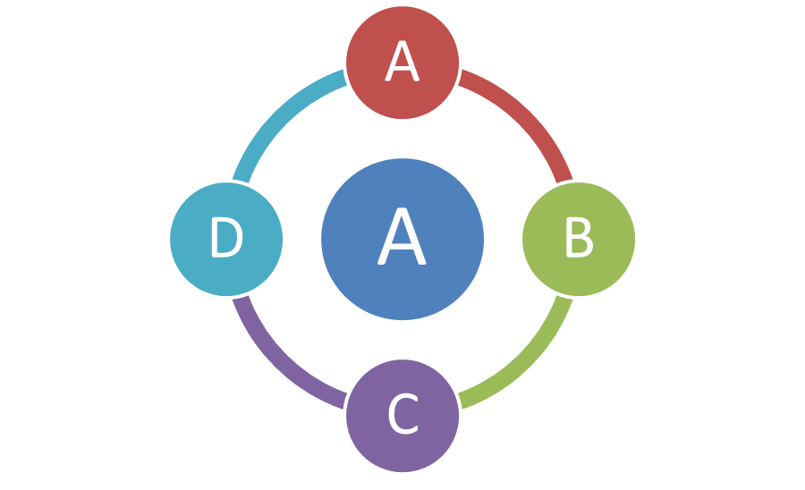
Figure 1 Figure caption should be of font size 10pt, Cambria, Centre align
Copy and paste here the content of the article. Copy and paste here the content of the article. Copy and paste here the content of the article. Copy and paste here the content of the article. Copy and paste here the content of the article. Copy and paste here the content of the article. Copy and paste here the content of the article. Copy and paste here the content of the article. Copy and paste here the content of the article. Copy and paste here the content of the article. Copy and paste here the content of the article.
Table 1 Table title should be of font size 10pt, Cambria, justify
SN. | Model Type | Seismic Zone | Displacement
1 | Model-A | 4 | 10.044 mm
2 | Font size 10 | Cambria | No space after paragraph
3 | Font size 10 | Cambria | No space after paragraph
4 | Font size 10 | Cambria | No space after paragraph
5 | Font size 10 | Cambria | No space after paragraph
6 | Font size 10 | Cambria | No space after paragraph
7 | Font size 10 | Cambria | No space after paragraph
8 | Font size 10 | Cambria | No space after paragraph
9 | Font size 10 | Cambria | No space after paragraph
Table foot note should be Font size 8, Cambria, Centre aligned, No space before paragraph
Copy and paste here the content of the article. Copy and paste here the content of the article. Copy and paste here the content of the article. Copy and paste here the content of the article. Copy and paste here the content of the article. Copy and paste here the content of the article. Copy and paste here the content of the article. Copy and paste here the content of the article. Copy and paste here the content of the article. Copy and paste here the content of the article. Copy and paste here the content of the article.

Conclusion
Author should provide an appropriate conclusion to the article. Write conclusion as single para. Conclusion should be concise, informative and can be started with summarizing outcome of the study in 1-2 sentence and ended with one line stating: how this study will benefit to the society and way forward.

Ethical Declarations
Acknowledgments
Acknowledgments must be inserted here.
Funding
Provide funding source details if any.
Disclosure of conflict of interest
If two or more authors have contributed in the manuscript, the conflict of interest statement must be inserted here. When no conflict of interest exists author should write as “The authors declare no conflicts of interest regarding this manuscript”.
Statement of ethical approval
If studies involve use of animal/human subject, authors must give appropriate statement of ethical approval. If not applicable then mention ‘The present research work does not contain any studies performed on animals/humans subjects by any of the authors’.
Statement of informed consent
If studies involve information about any individual e.g. case studies, survey, interview etc., author must write statement of informed consent as “Informed consent was obtained from all individual participants included in the study.”
Data Availability Statement
The data supporting the findings of this study are available from the corresponding author upon reasonable request.
AI Usage Statement
Authors must disclose any use of Artificial Intelligence (AI) or generative AI tools during the preparation of the manuscript. AI technologies may be used only as supportive tools (e.g., language editing, grammar correction, formatting, data analysis, coding, or figure preparation). If no AI tools were used, authors should state: "The authors declare that no Artificial Intelligence (AI) tools or generative AI technologies were used in the preparation of this manuscript.".

References
- Author AA, Author BB, Author CC. Write here article title of reference. Journal Name. 20XX Dec; x(x): xx-xx.
- Author AA, Author BB, Author CC. Write here article title of reference. Journal Name. 20XX Dec; x(x): xx-xx.
- Author AA, Author BB, Author CC. Write here article title of reference. Journal Name. 20XX Dec; x(x): xx-xx.
- Author AA, Author BB, Author CC. Write here article title of reference. Journal Name. 20XX Dec; x(x): xx-xx.
- Author AA, Author BB, Author CC. Write here article title of reference. Journal Name. 20XX Dec; x(x): xx-xx.

